**ACM-ASC Internship 2024**

**Milestone II : Phase II**

____________________________________________________________________________________________________

**TAG 3 : AI and Disabilities Studies**

**Group ID: DIS10**

**Project Mentor: Dr. Namitha K**

**Project Lead: Girish S**

**Title: AI for Neurodiversity**

**Team Members**

| Girish S | AM.EN.U4AIE22044 |
| --- | --- |
| Anuvind MP | AM.EN.U4AIE22010 |
| R S Harish Kumar | AM.EN.U4AIE22042 |
| Harishankar Binu Nair | AM.EN.U4AIE22023 |

____________________________________________________________________________________________________

**Literature Review**

| **Research Papers** | **Read-By** | **Status** |
| --- | --- | --- |
| Rethinking autism: implications of sensory and movement differences for understanding and support - DOI: [**10.3389/fnint.2012.00124**](https://doi.org/10.3389/fnint.2012.00124) | Harish | Approved |
| An Autoencoder-Based Deep Learning Classifier for Efficient Diagnosis of Autism - DOI: [**10.3390/children7100182**](https://doi.org/10.3390/children7100182) | Harish | Approved |
| Deep Learning for neuroimaging-based diagnosis and rehabilitation of Autism Spectrum Disorder: A review - DOI: [**10.1016/j.compbiomed.2021.104949**](https://doi.org/10.1016/j.compbiomed.2021.104949) | Girish | Approved |
| PREDICTING AUTISM DIAGNOSIS USING IMAGE WITH FIXATIONS AND SYNTHETIC SACCADE PATTERNS **DOI: 10.1109/ICMEW.2019.00125** | Girish | Approved |
| Eye Tracking-Based Diagnosis and Early Detection of Autism Spectrum Disorder Using Machine Learning and Deep Learning Techniques **DOI: 10.3390/electronics11040530** | Girish | Approved |

1. **Rethinking autism: implications of sensory and movement differences for understanding and support**

-> Researchers have noted the presence of impairments in basic motor skills: gait, posture, balance, speed, coordination in individuals with autism.

-> Individuals with autism often are aware of their idiosyncrasies,may not able to control them but do want communication, participation, and relationship.

-> Characteristic features of substantial movement disturbances and evidence possible overlap symptoms in autism.

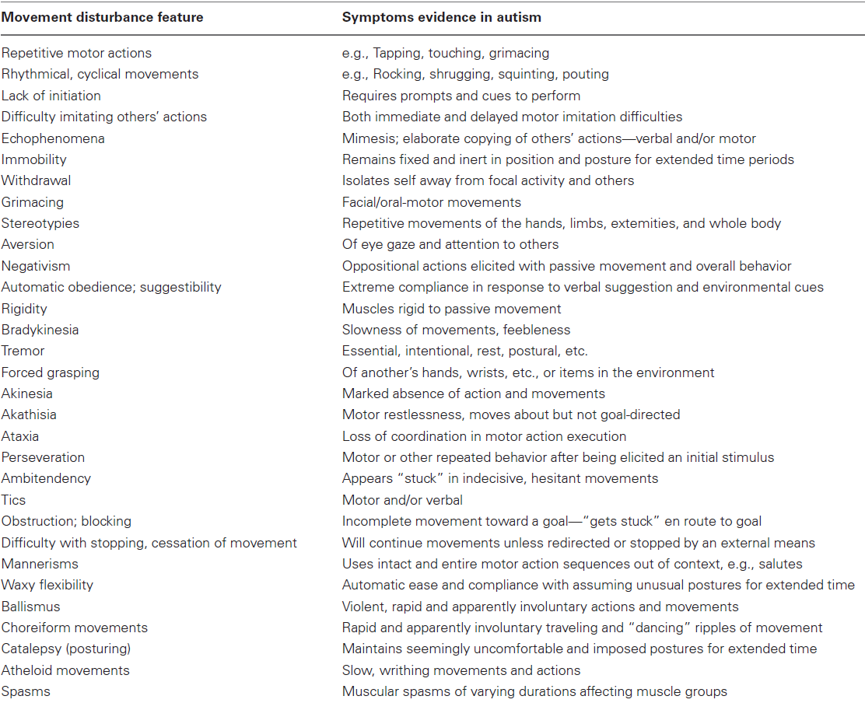

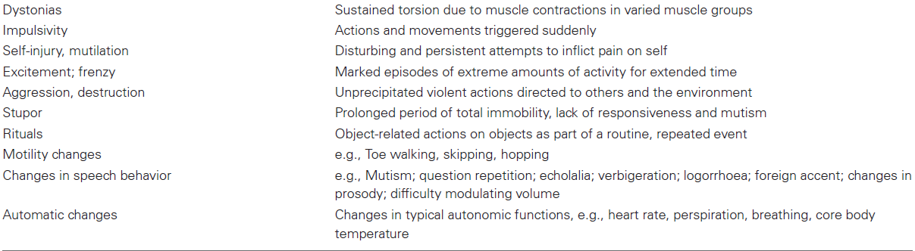

# **An Autoencoder-Based Deep Learning Classifier for Efficient Diagnosis of Autism**

-> Various machine learning and deep neural network methods distinguish between ASD and non-ASD. These methods are categorized into three main categories as

- Image-based (by using large brain image datasets from ABIDE)

- Questionnaire-based (using crowdsource requirement procedure)

- Behavioural-based

-> This paper proposed to classify ASD for diagnosis using an autoencoder hybrid classifier

-> The input data is 1112 fMRI images from ABIDE

-> Autoencoder is used for dimensionality reduction. This methodology proposed in this paper is :   
- First input data is given to the undercomplete autoencoder  
- The output of the autoencoder is then given to various machine and deep learning models such as CNN, KNN, SVM, RF

- The result of all these models are compared

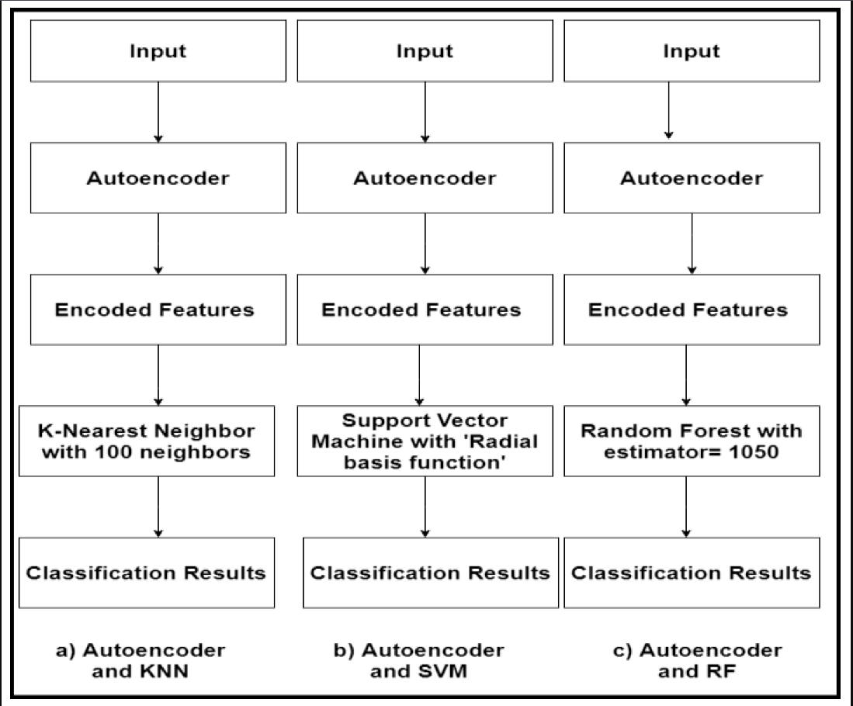

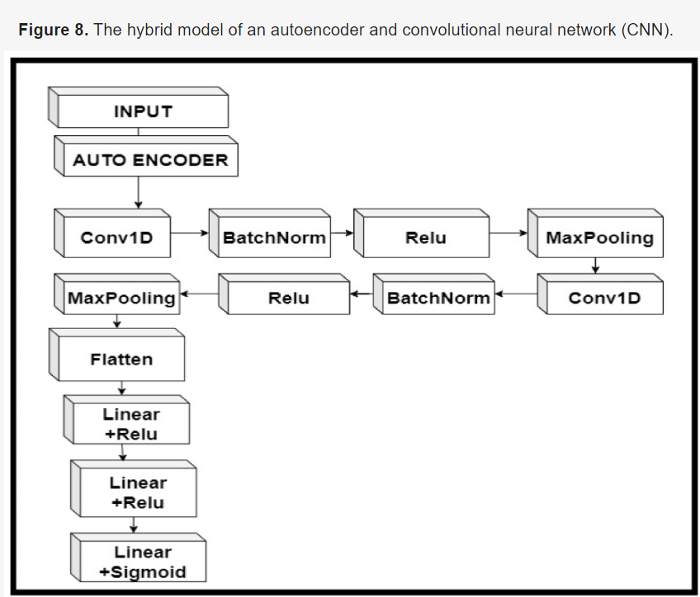

-> The hybrid of autoencoder and CNN was the most accurate in classification with an accuracy of 84.05%

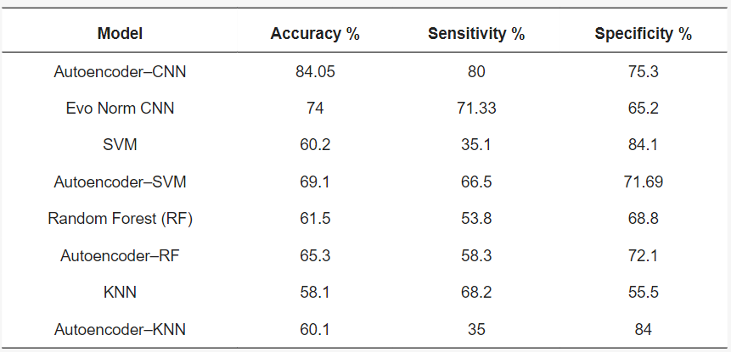

-> Percentage of improvement in accuracy, sensitivity and specificity

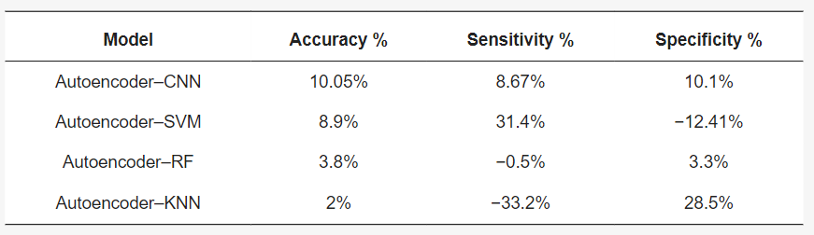

-> They also found out that using an autoencoder and a classifier as a hybrid model is more successful and accurate than just using a classifier alone

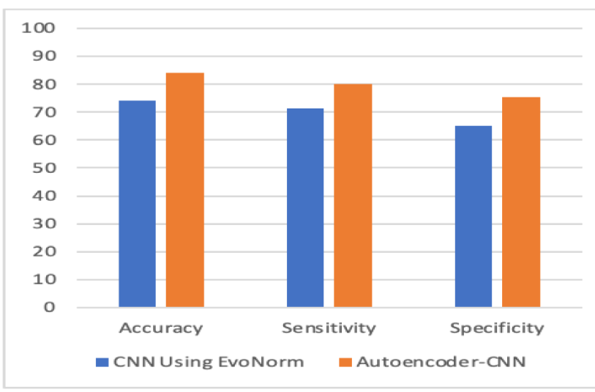

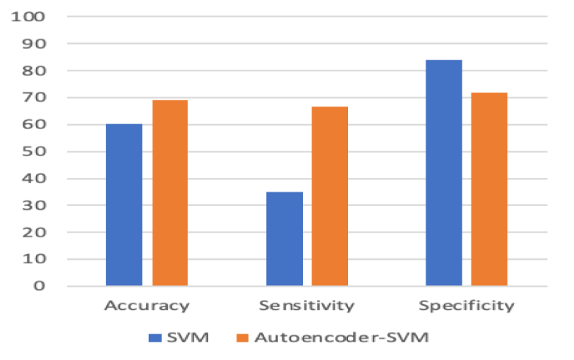

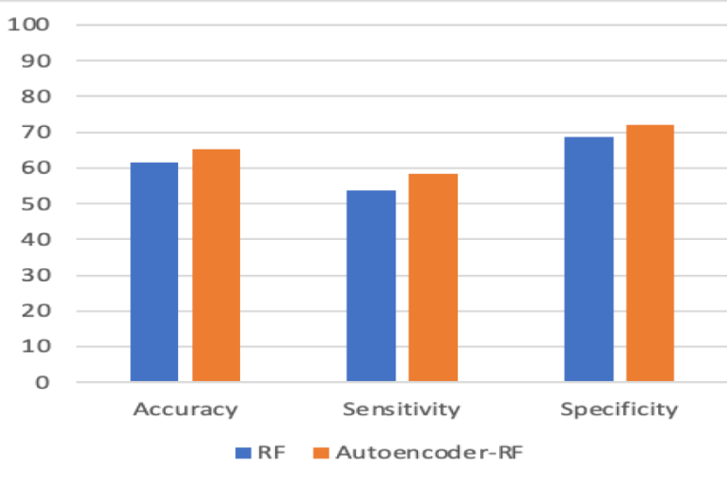

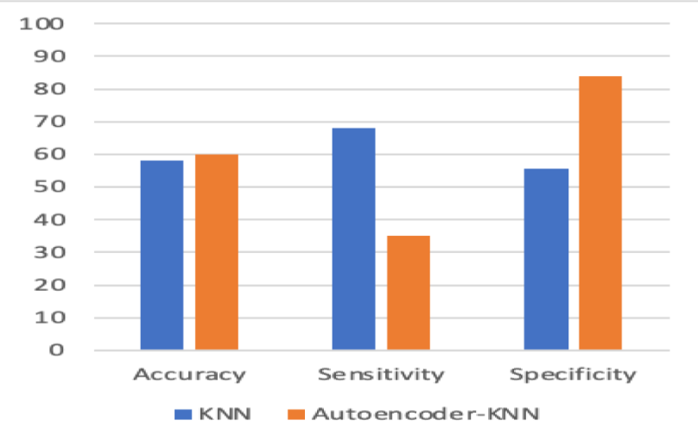

-> The ROC(receiver operating characteristics) curve and AUC(area under curve) for autoencoder-CNN hybrid was better than any other model

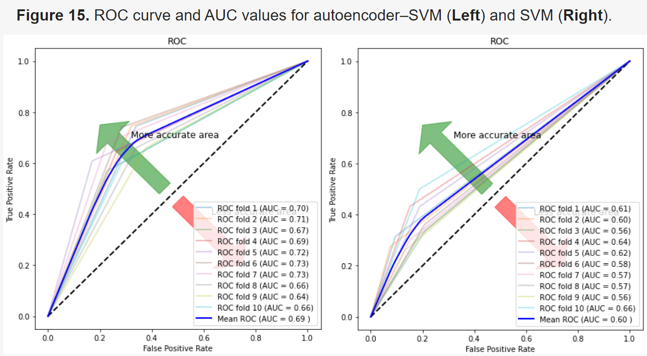

-> The ROC curve and AUC is better for all the hybrid models compared to their non hybrid classifiers

-> The autoencoder-CNN hybrid also achieved better F1 score than all other models

F1 = 2×(𝑝𝑟𝑒𝑐𝑖𝑠𝑖𝑜𝑛×𝑟𝑒𝑐𝑎𝑙𝑙)/(𝑝𝑟𝑒𝑐𝑖𝑠𝑖𝑜𝑛+𝑟𝑒𝑐𝑎𝑙𝑙)

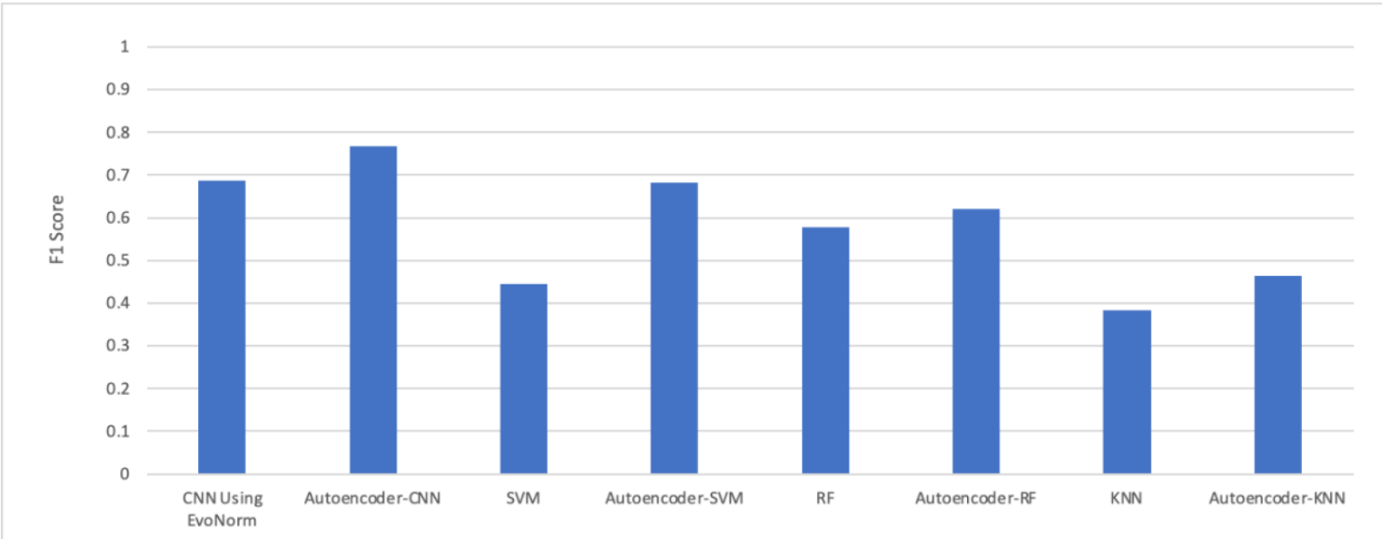

-> The autoencoder-CNN hybrid took the most computational time for training compared to other models

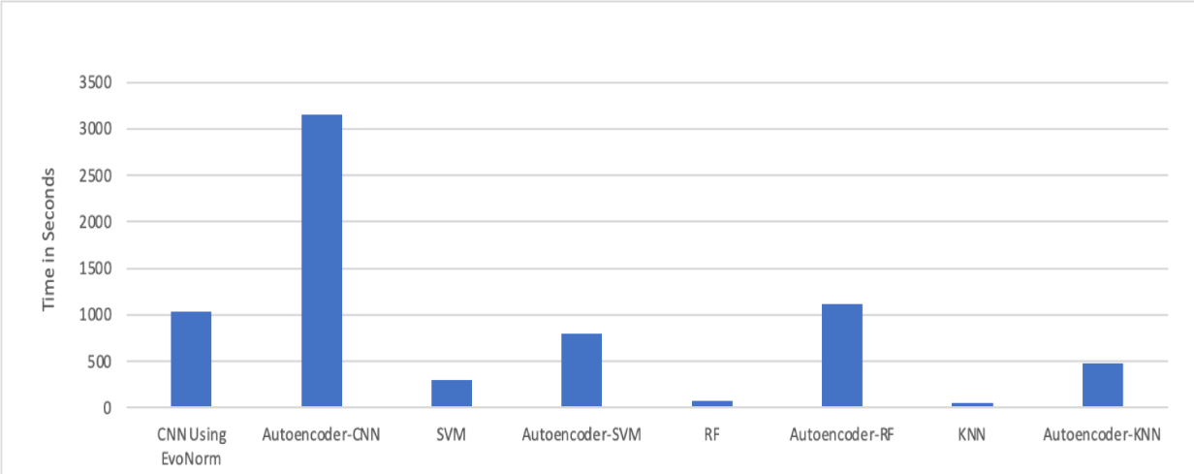

1. **Deep learning for neuroimaging-based diagnosis and rehabilitation of Autism Spectrum Disorder: A review**

**DOI: 10.1016/j.compbiomed.2021.104949**

-> Neuroimaging techniques are non-invasive disease markers potentially useful for ASD diagnosis

-> Structural and functional neuroimaging techniques provide physicians substantial information about the structure (anatomy and structural connectivity) and function (activity and functional connectivity) of the brain

-> past ASD was divided into five groups: Asperger’s syndrome (AS), Rett syndrome (RS), childhood disintegrative disorder (CDD), autistic disorder (classic autism), and pervasive developmental disorder – not otherwise specified (PDD-NOS)

-> current ASD classification is now categorized into 3 security levels

Level 1 - Needs support

Level 2 - Needs substantial support

Level 3 - Needs very substantial support

-> transcranial magnetic stimulation (TMS) is a non-invasive brain stimulation method based on electromagnetic induction that concentrates on the brain areas that play an essential role in adjusting the behavior of ASD patients

-> transcranial direct current stimulation (tDCS) is a non-invasive brain stimulation method that employs direct electric currents to stimulate certain parts of the brain

-> various tools that psychiatrists use are as follows

* autism diagnostic observation schedule 2nd edition (ADOS-2)
* autism diagnostic interview-revised (ADI-R)
* childhood autism rating scale (CARS)
* diagnostic interview for social and communication disorder (DISCO)
* Gilliam autism rating scale (GARS)
* developmental, dimensional, and diagnostic interview (3di)
* modified checklist for autism in toddlers (M-CHAT)

-> datasets -> ABIDE I and ABIDE II

-> pre processed dataset -> PCP and MLLE

-> total 1114 entries

-> another dataset used is EEG dataset by King Abdulaziz University (KAU) Brain Computer Interface (BCI) Group

-> various data preprocessing is done and classified into 2

* Standard (low-level) fMRI preprocessing steps
* Standard (low-level) sMRI preprocessing steps
* High-level preprocessing steps
  + Brain extraction
  + Spatial smoothing
  + Temporal filtering
  + Motion correction
  + Slice time correction
  + Intensity normalization
  + Registration to a standard atlas
  + neuroimaging analysis kit (NIAK)
  + data processing assistant for rs-fMRI (DPARSF)
  + the configurable pipeline for the analysis of connectomes (CPAC)
  + connectome computation system (CCS)
  + Denoising
  + Inhomogeneity correction
  + Intensity standardization
  + De-oblique
  + Re-orientation
  + Segmentation
  + sliding window (SW)
  + data augmentation (DA)
  + functional connectivity matrix (FCM) estimation
  + fast Fourier transformation (FFT)

-> CNN, RNN, AE, DBN, CNN-RNN, and CNN-AE models are examined in this review

-> data such as sMRI, DTI, rsfMRI, T-fMRI, fNIRS, and EEG with their data in 1D, 2D, and 3D format are explored.

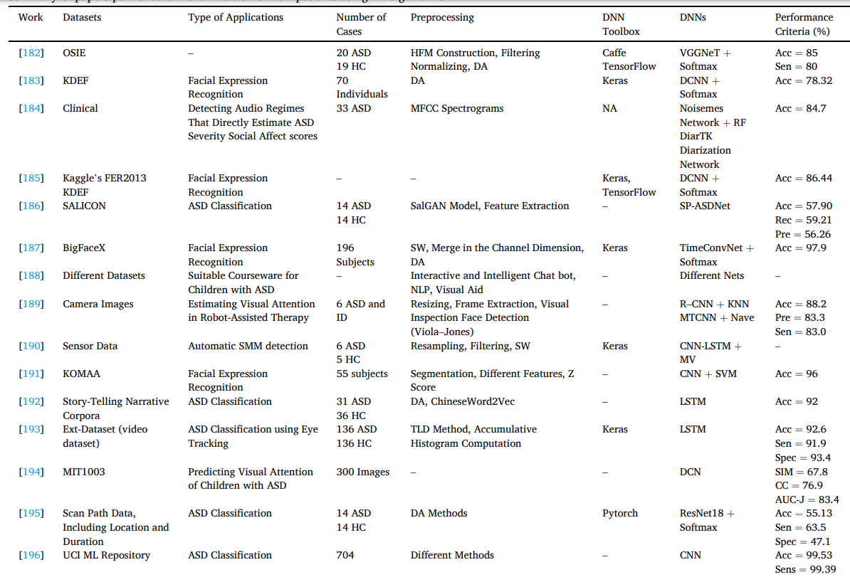

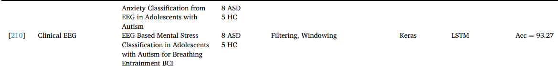

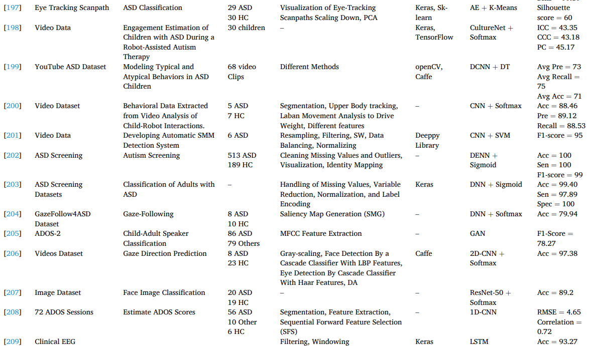

1. **PREDICTING AUTISM DIAGNOSIS USING IMAGE WITH FIXATIONS AND SYNTHETIC SACCADE PATTERNS**

**DOI: 10.1109/ICMEW.2019.00125**

-> First signs of ASD appears early to under age of 3

-> most diagnosis interviews happen after age 3 (it is done at age 4 in USA)

-> this paper presents the need for early diagnosis of ASD in toddlers and children under the age of 3 when the brain is most malleable.

-> proposes 2 DL model techniques

-> both uses the [Gaze dataset](https://zenodo.org/records/2647418)

-> generative model of synthetic saccade patterns STAR-FC

-> in STAR-FC, the model generates the scanpath for the typically developed(TD) childrens and adds the inputted scanpath of the children to the input for the classifier

-> in the second approach, the image + the fixation heat map is fed into the CNN network for learning

-> “a deep neural network has been jointly trained on real scan path in conjunction with synthetic scan path generated by STAR-FC. Since STAR-FC is trained on general population, it is assumed that it models the scan path of TD subjects.”

-> the data consists of timestamps, x-y coordinates, horizontal and vertical eye gaze coordinates.

-> these data are then combined into scan paths by connecting with 3 different distance measures

-> Dynamic Time Warping (DTW), Hausdorff distance and Frechett distance are computed between the normalized real and synthetic scan-path

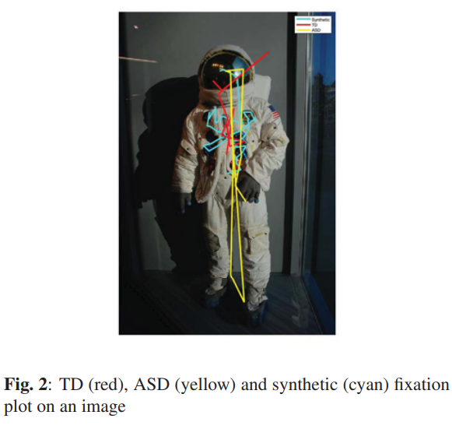

Example data ^

-> 2 fully connected dense networks are trained separately

-> the first model has reduced set of high level features

-> 7 features => duration, total number of fixation points, mean, variance, three distance measures (DTW, Hausdorff, Frechett) => 7 dimensional input features

-> input layer has batch normalization

-> 8 fully connected layer with 7 neurons each and SELU activation has been applied

-> output layer has one-hot coded (probably 2 neurons TD and ASD)

-> trained for 200 epochs, binary cross entropy loss function and L2 regularizer with ADAMs optimizer

-> batch size = 128, has 492 trainable parameters

-> second model is a deeper network with 10 fully connected layers

-> the input vector dimension is 1D with 47 elements, with the previous 7 and the 20 points from real scanpath and the 20 points from synthetic scanpath.

-> input -> 128 -> 256 -> 512 -> 1024 -> 512 -> 128 -> 64 -> 16 -> output

-> output is one-hot coded

-> batch normalization and dropout of 0.3 have been applied on all hidden layers

-> 300 epochs, 0.001 learning rate, batch size = 32, 1402560 trainable parameters

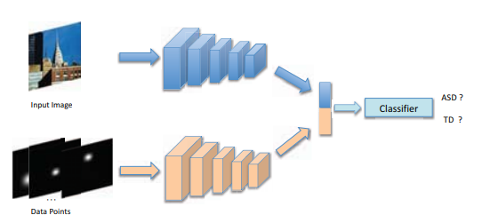

-> the network is split into 2 branches

-> first part extracts the features of the images

-> second part processes the data points

-> the data points are gaze points D = {(x, y, d)} where (x, y) is the data point and d is the duration of Gaze

-> two branches are fused together to classify output

-> 300 images, 6050 samples, 80-20 split for validation

-> some noise has been added to both the input image and the data points, since the dataset is small and to avoid overfitting

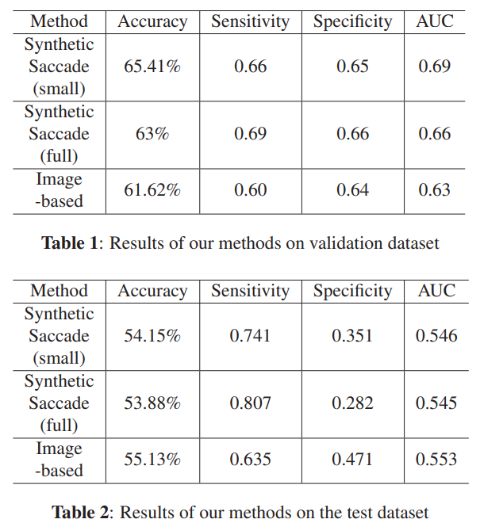

-> from the results, we can infer that training and testing data was imbalanced and due to the noise added in the data augmentation part the model couldnt learn the features properly. Also to note that the dataset only contains 300 images thus with reduced data the model was only able to learn this much

# **Eye Tracking-Based Diagnosis and Early Detection of Autism Spectrum Disorder Using Machine Learning and Deep Learning Techniques**

**DOI: 10.3390/electronics11040530**

-> Dataset: Figshare data repository

<https://figshare.com/articles/dataset/Visualization_of_Eye-Tracking_Scanpaths_in_Autism_Spectrum_Disorder_Image_Dataset/7073087/1>

-> 547 images of asd with 219 ASD and 328 TD children

-> proposes 3 techniques in the paper

-> ML model, DL model, a hybrid between the 2

* + FFNN and ANN based on local binary pattern LBP and gray level co-occurrence matrix GLCM
  + Pre-trained CNN -> GoogleNet and ResNet-18
  + GoogleNet+SVM and ResNet-18+SVM

-> classification problem -> classes: lower SVA and TD (SVA: social visual attention)

-> The data is first processed

-> Pre-processing -> applying Average and Laplacian filters of 5x5

-> Segmentation and feature extraction

-> a snake model was applied for segmentation, extracting ROIs and isolation of them

-> from that LBP and GLCM was used for feature extraction

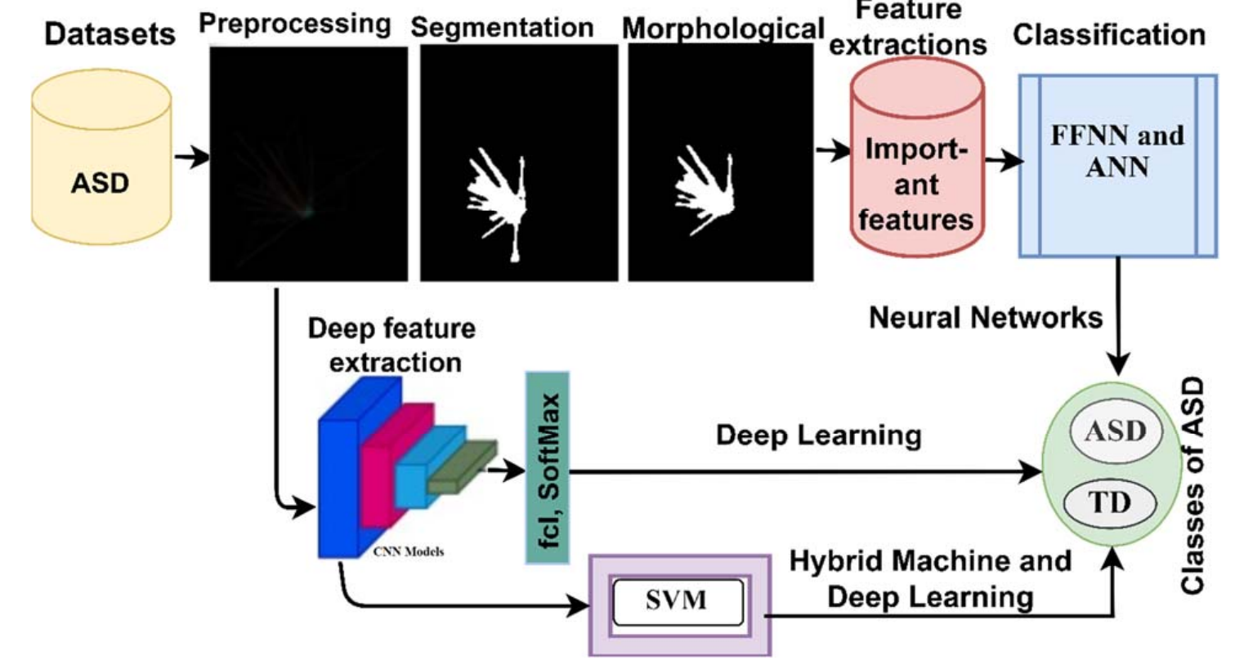

-> morphological method contain 2 processes => ‘fits’ and ‘hits’

-> fits => adjacent union test and hits => tests the adjacent intersection

-> this morphological method produced improved binary images

-> in the first method, the ANN contains 10 FC dense layers with 216 neurons

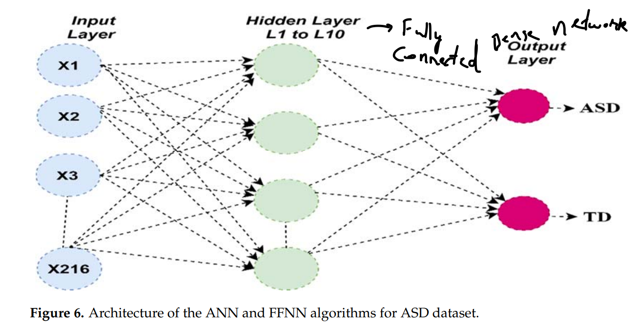

-> the second method uses the pre trained models GoogleNet and ResNet-18

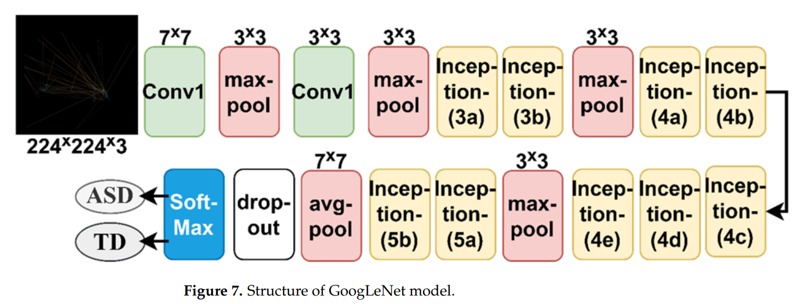

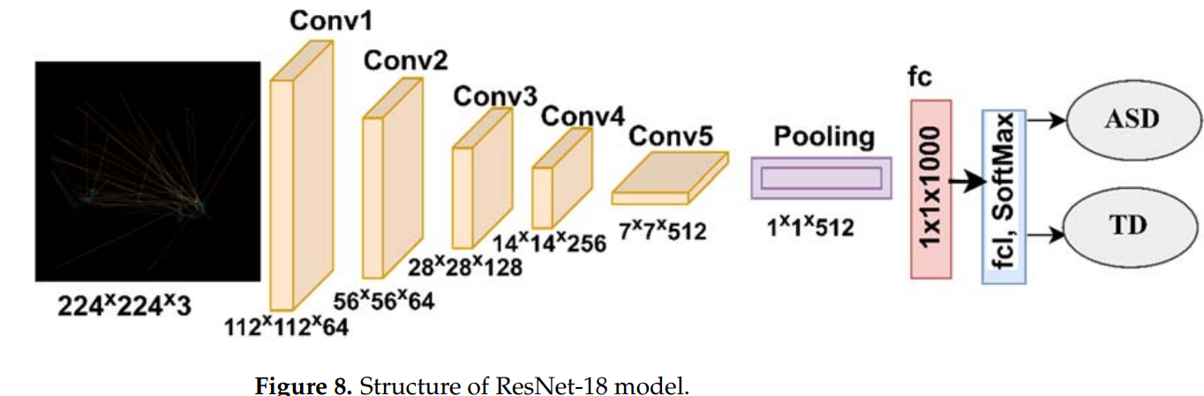

-> the third method just removes the last fully connected layer with SoftMax activation and replaces with the SVM block for classification

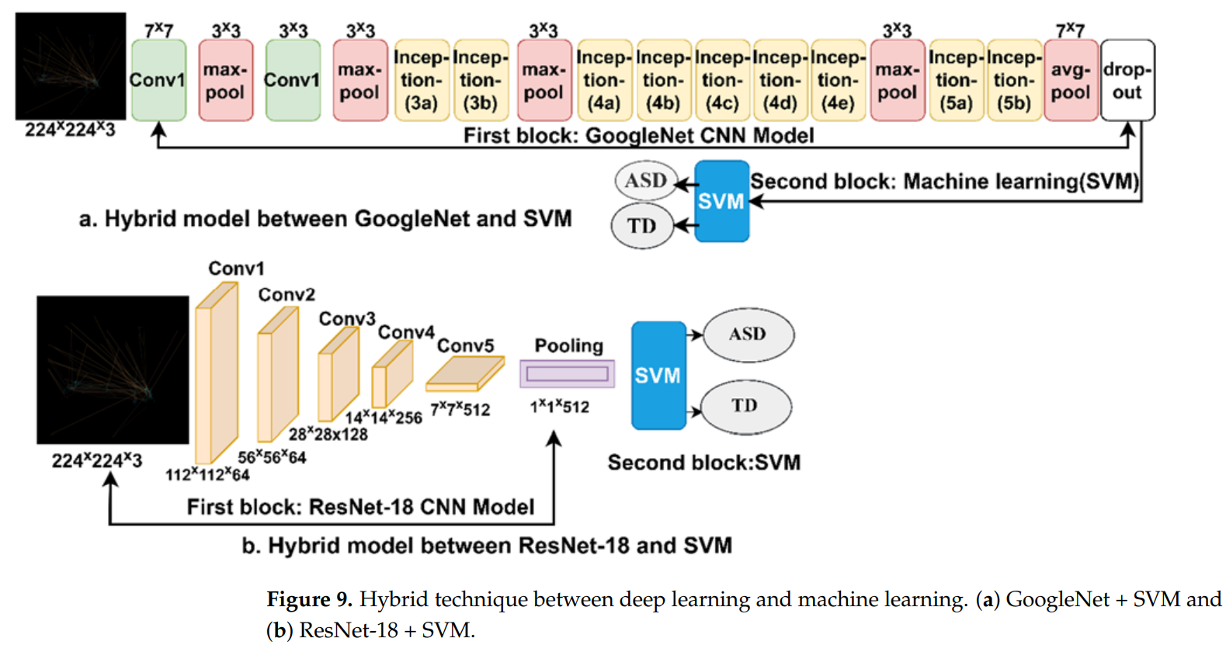

-> the data was split in 80-20 ratio -> 80 for training and 20 for testing

-> further divided the training data into training and validation with 80-20

-> the data was split in the ratio 64% **:** 16% **:** 20% - Training **:** Validation **:** Testing

-> the evaluation metrics used are as follows

Accuracy

Precision

Sensitivity

Specificity

AUC

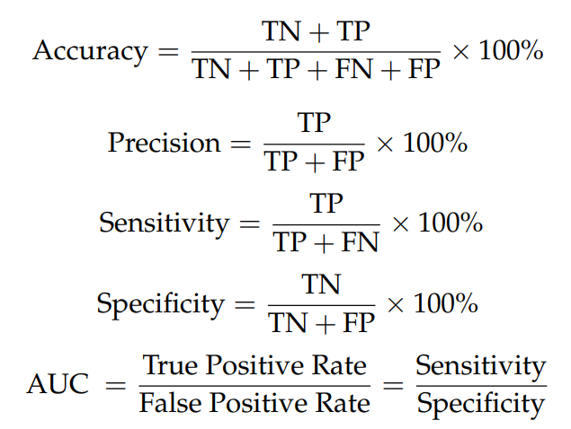

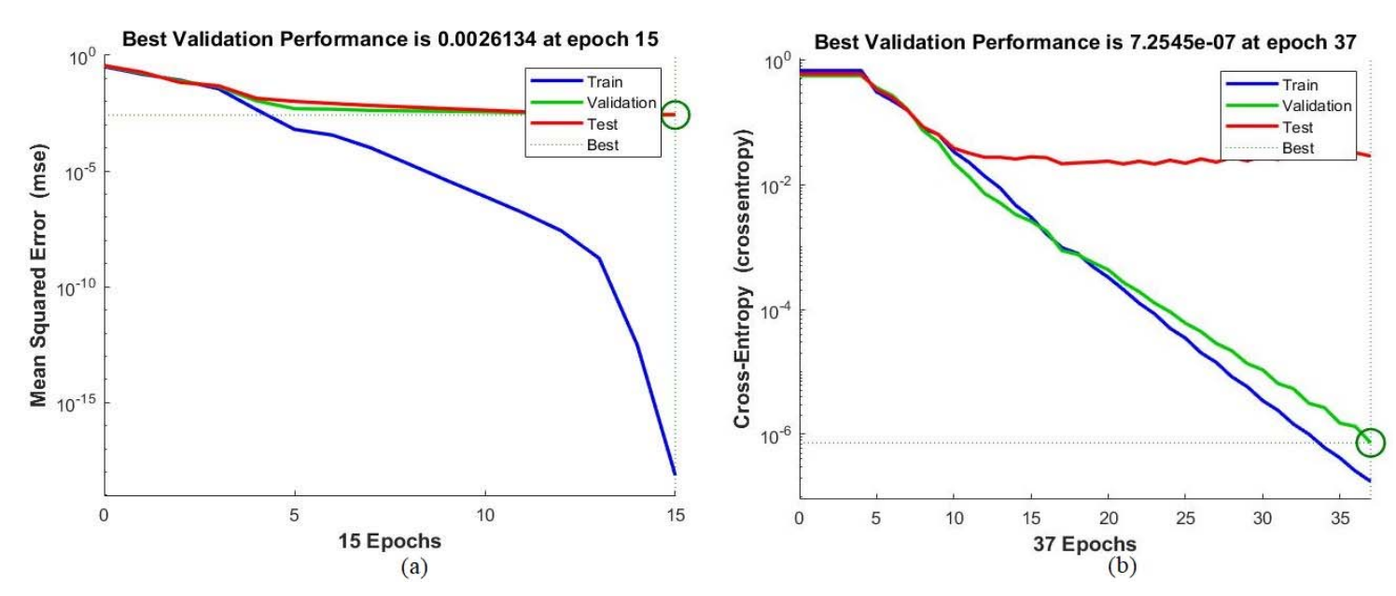

ROC(Receiver operating characteristics) was found to be 99.77%

